Thesis Plan
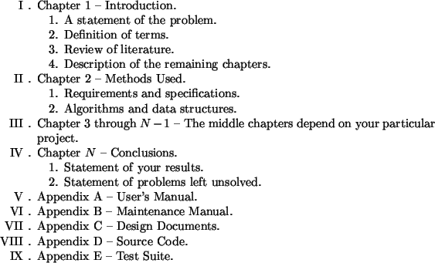
https://cs.fit.edu/~wds/guides/howto/

Statement of the Problem
General background of the problem.
Relation to deaf, hard of hearing and foreign languages.
Mathematical formulation, either in general or as I have interpreted it. This comes with definition of terms.

Review of Literature
In depth review of the 2 papers that deal most closely with my problem. Should I describe the methods they used here? I think I need to describe the key methods in order to make sense of the literature.
Broader look at similar applications, i.e. ASR, what has been the most successful techniques and what is the most current.
- Other feature extraction methods (i.e. filterbanks and ….)
- Other machine learning methods

Methods Used
Preprocessing & Feature Extraction
- Extraction of audio, compression (mp3 vs wav)
- Sampling of signal – choice of sample rate
- Consideration of noisy inputs
- MFCC’s, look at other methods of feature extraction
- srt and probability array

Data Acquisition
Recording of live audio with phone using mp3 compression

Learning
Choice of convolution NN based on literature, why it is superior over recurrent neural nets.
Other ML algorithms
Learn on clean signal and try on noisy dataset after?

Results

Conclusion

